ANS1. https://github.com/priyanshu599/SummerSchool2026.git

ANS2. 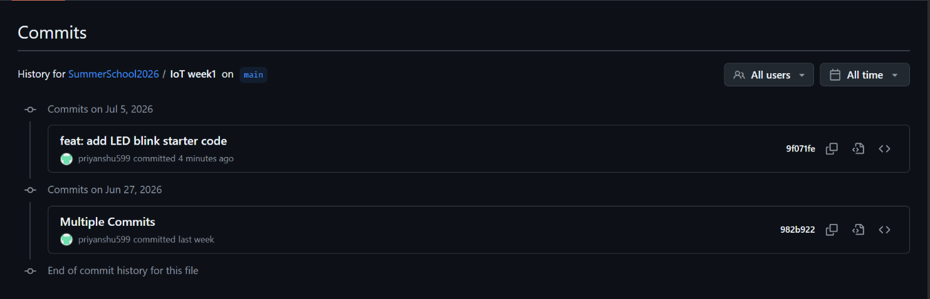

ANS3. https://github.com/priyanshu599/SummerSchool2026/commit/839bb40b88e56de65cb 8ede193f0cf77e6bb30b5

Section B: Practical Tasks (4 marks each)
ANS4.
I progressively improved the LED Blink project by creating four separate Git commits to demonstrate version control using Git.
Version History:
v1.0
- Implemented the basic LED Blink program.
- LED blinks every 500 ms.

v1.1
- Added Serial Monitor support.
- Displayed the blink count after each blink.

v1.2
- Connected a potentiometer to control the LED blinking speed.
- Used analogRead() and map() to vary the delay dynamically.

v1.3
- Added a professional comment header containing:
  - Author Name
  - Roll Number
  - Date
  - Project Description
Commit Messages: 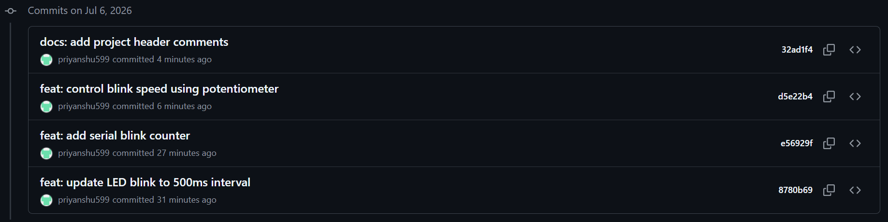
GitHub Repository
https://github.com/priyanshu599/SummerSchool2026/tree/main/IoT%20week1/led_blink

ANS5.
A professional README.md file was created for the LED Blink project. It includes:
- Project Title
- Project Overview
- Hardware Required
- Circuit Diagram Description
- Step-by-step code upload instructions
- Expected Output
- Troubleshooting Tips
- Author Details
The README helps users understand the project, hardware setup, and execution process, making the project easy to use and maintain.
GitHub Repository:
https://github.com/priyanshu599/SummerSchool2026/blob/main/IoT%20week1/led_blink/README.md

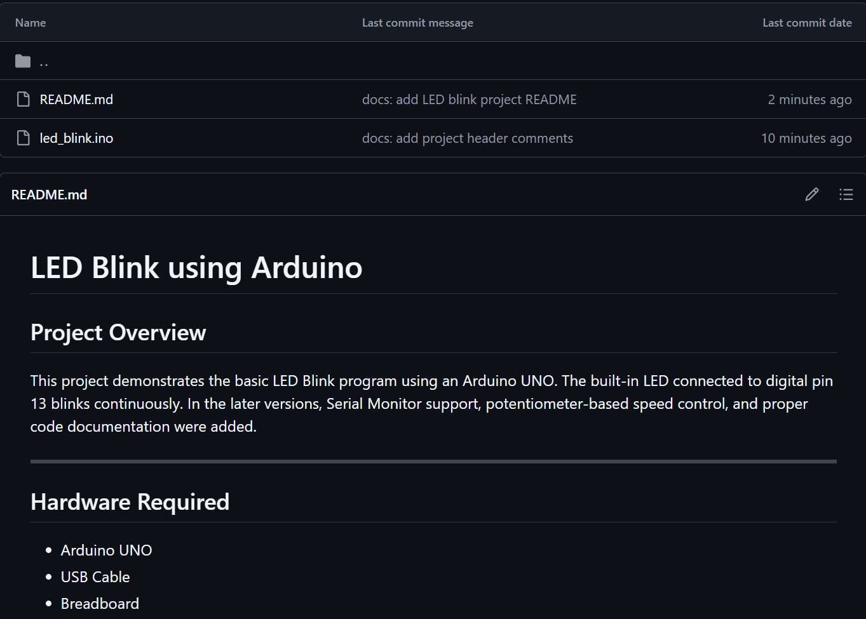

ANS6.
Three GitHub Issues were created to manage bugs and future improvements in the LED Blink project.
The following Issues were added:
- Bug: Blink interval not changing when potentiometer is at maximum.
- Feature: Add RGB LED support.
- Enhancement: Log Serial Monitor data in CSV format.
All issues were assigned to me and linked to the milestone Week 1 Completion.
One issue was automatically closed using a Git commit containing the keyword Fixes #IssueNumber.
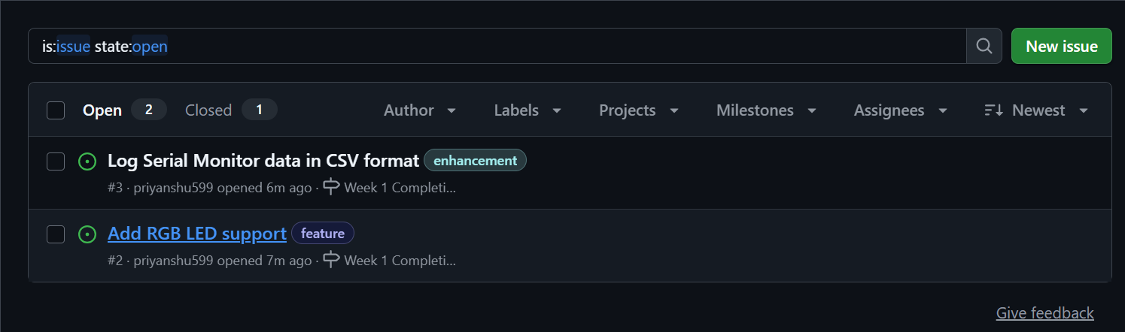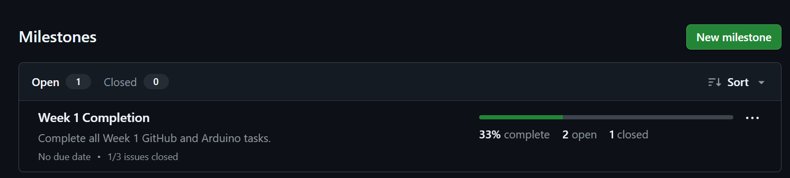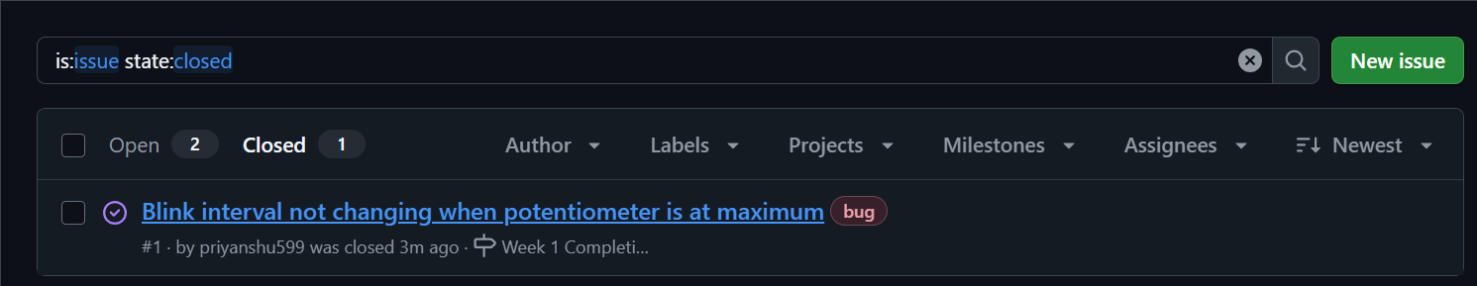

ANS7.
A partner's GitHub repository was forked successfully. A modified LED Blink program was added that blinks the LED three times rapidly and pauses for two seconds before repeating. The changes were committed, pushed, and submitted as a Pull Request for review. After review, the Pull Request was merged into the original repository.
Partner Repository:
https://github.com/ShivamYadav30/IoT_Summer_school_2026

Pull Request URL:
https://github.com/ShivamYadav30/IoT_Summer_school_2026/pull/4#issue-4814474562
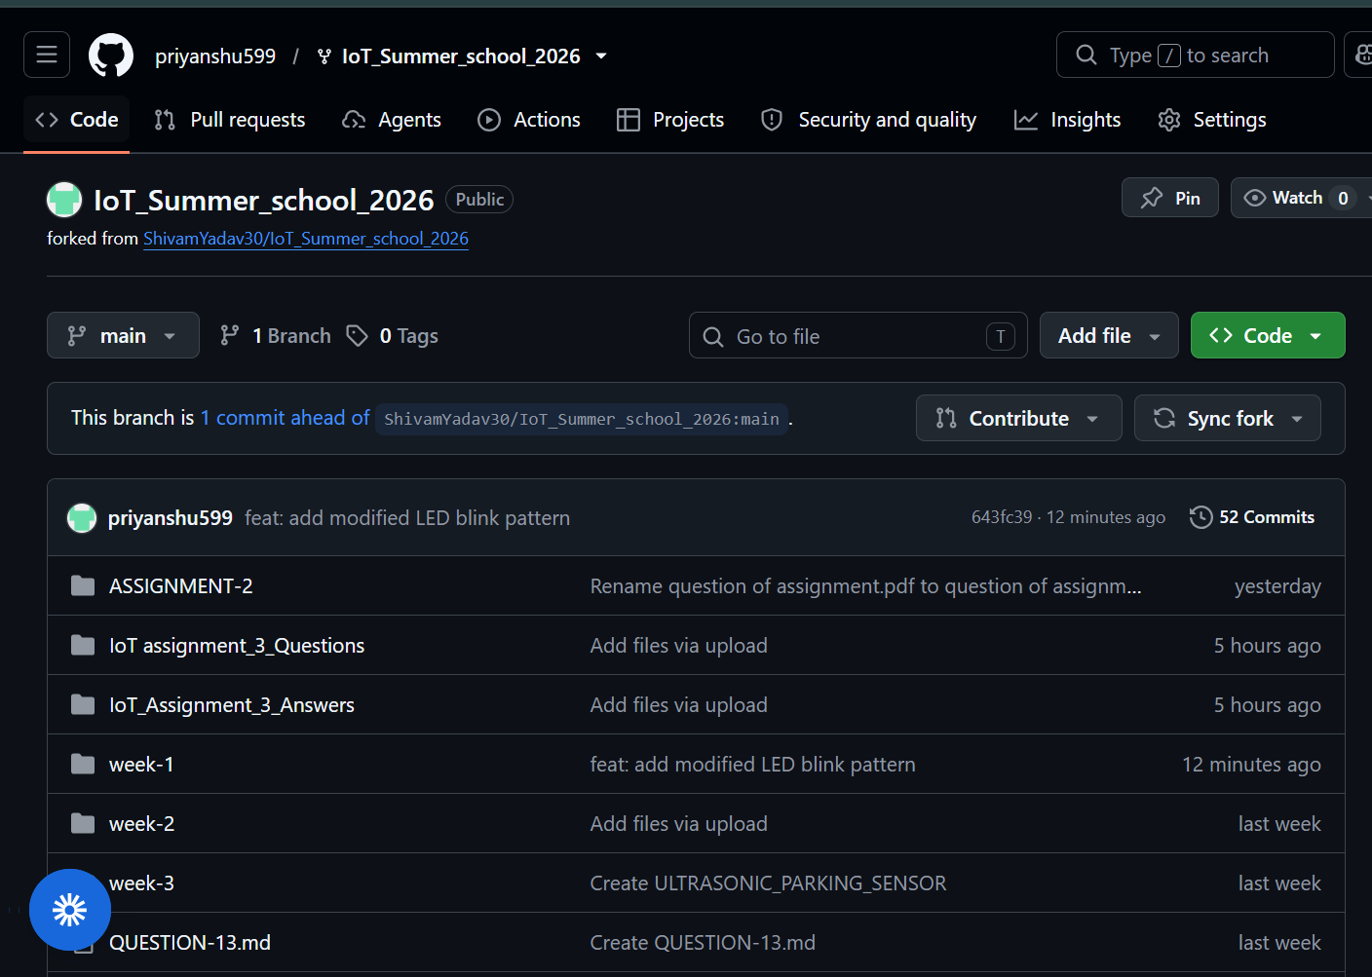
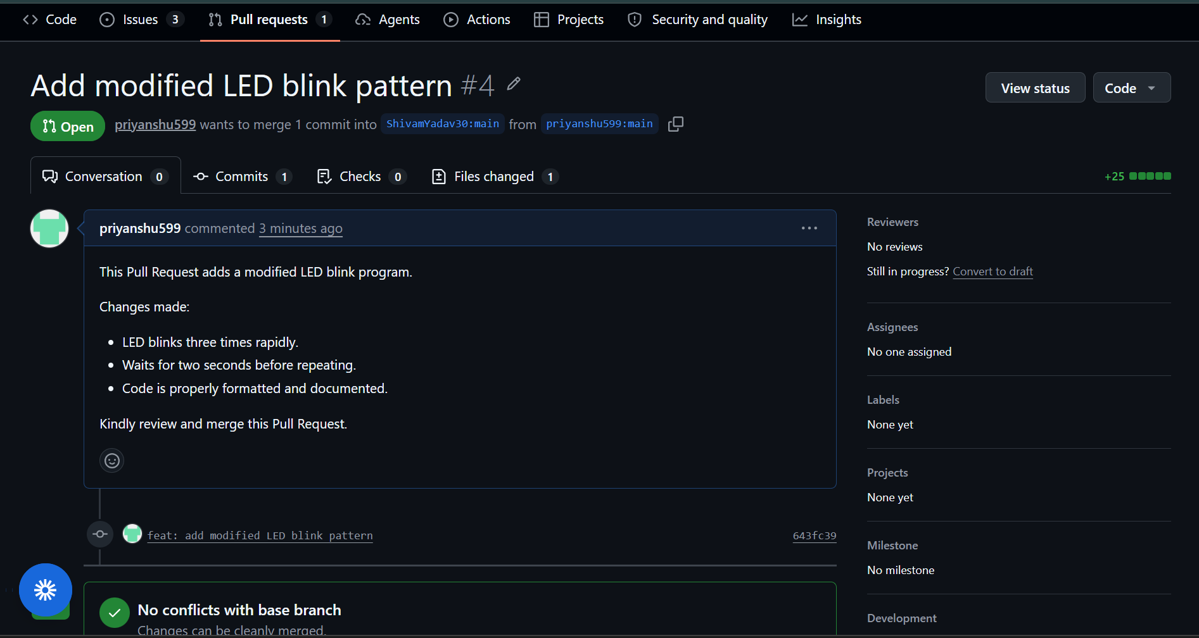

ANS8.
A GitHub Actions workflow was created to automate a simple Continuous Integration (CI) task. Whenever code is pushed to the repository, the workflow automatically runs a Python script that counts the number of Arduino (.ino) files and displays the count in the GitHub Actions log.
This demonstrates basic automation using GitHub Actions.
Workflow File:
https://github.com/priyanshu599/SummerSchool2026/tree/main/.github/workflows

Python Script:
https://github.com/priyanshu599/SummerSchool2026/tree/main/scripts
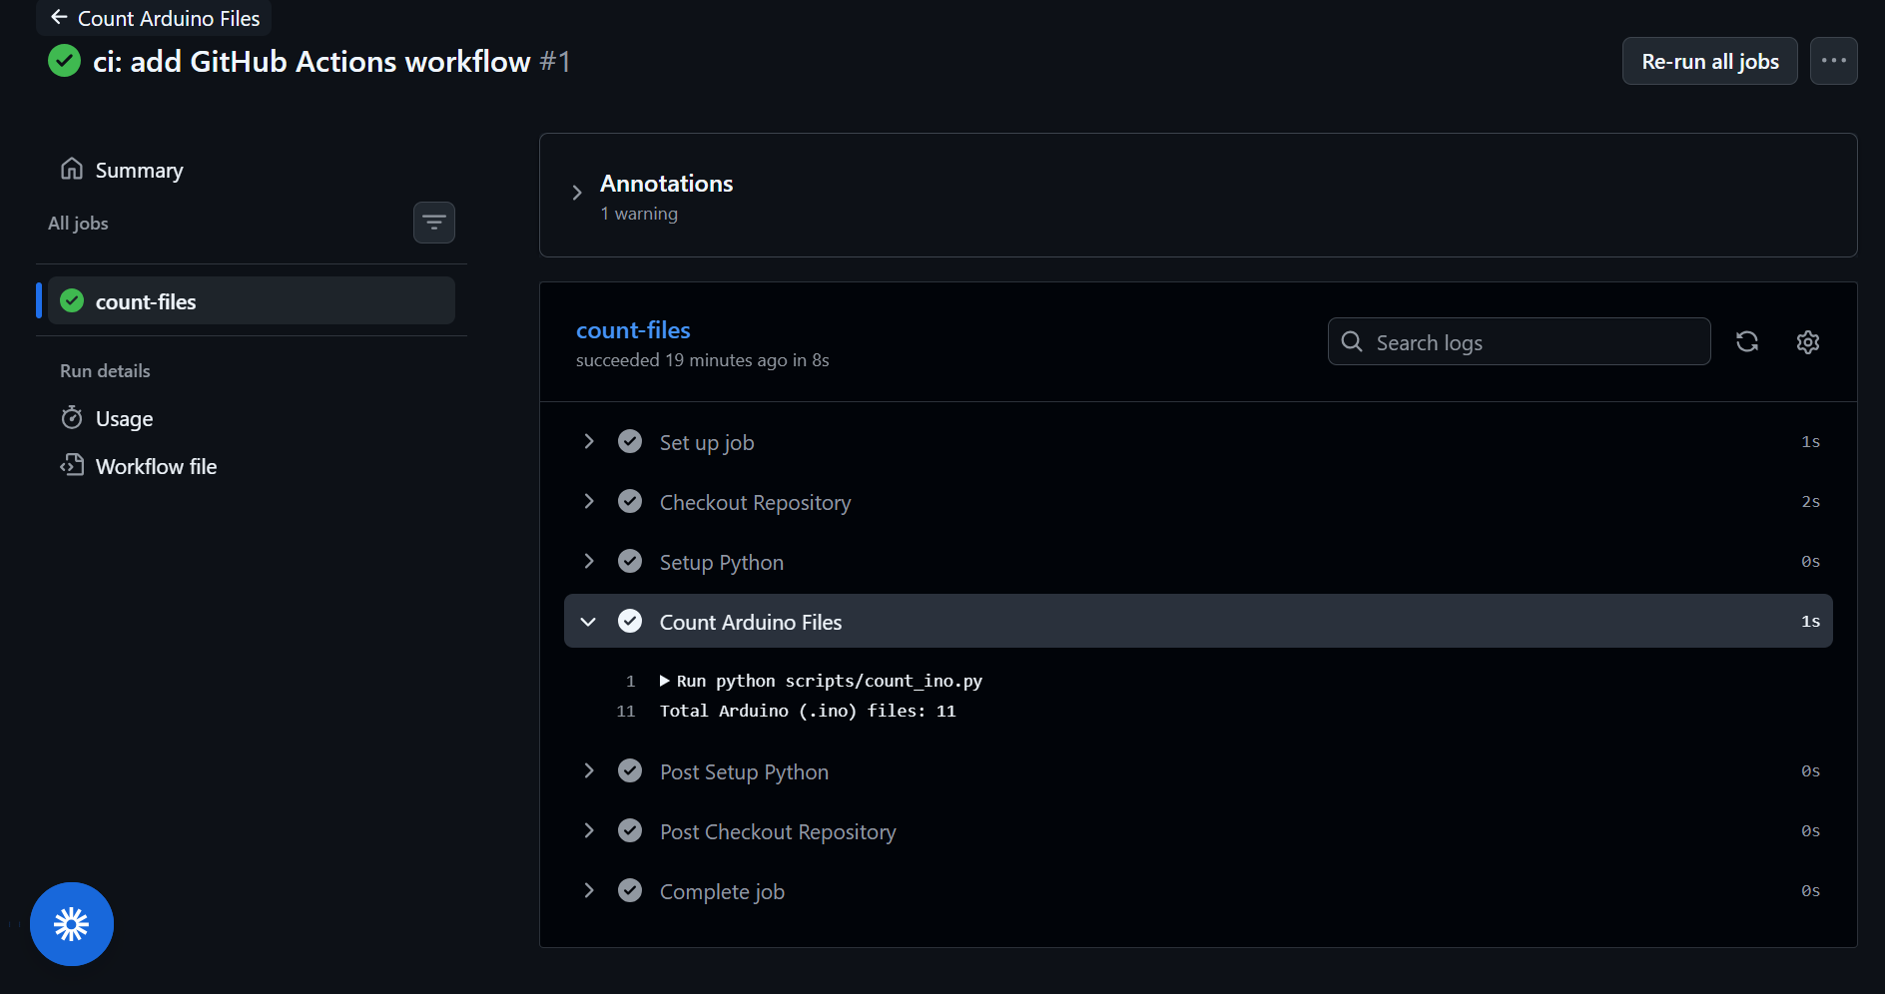

ANS9.
1. git clone
- git clone is used to copy an entire remote repository to your local computer.
- It downloads all files, branches, and commit history.
- It is mainly used when working on a repository for the first time.
Example:
git clone https://github.com/priyanshu599/SummerSchool2026.git
2. git fetch
- git fetch downloads the latest changes from the remote repository but does not merge them into the local branch.
- It allows you to review the changes before merging.
Example:
git fetch origin
3. git pull
- git pull downloads the latest changes from the remote repository and automatically merges them into the current local branch.
- It is commonly used to keep the local repository updated.
Example:
git pull origin main
When to Use Each
Command | Purpose | When to Use
git clone | Copies a repository to the local system | When working with a repository for the first time
git fetch | Downloads changes without merging | When you want to review updates before merging
git pull | Downloads and merges changes | When you want to update your local repository with the latest changes

ANS10.
A .gitignore file tells Git which files and folders should not be tracked or uploaded to the GitHub repository. It is useful for excluding temporary files, compiled files, build folders, and IDE configuration files that are not required in the project.
Using a .gitignore file keeps the repository clean, reduces unnecessary uploads, and prevents accidental sharing of unwanted files.
Sample .gitignore for an Arduino Project
# Compiled files
*.hex
*.elf
# Build folder
build/
# VS Code settings
.vscode/
# Operating System files
.DS_Store
Thumbs.db
# Temporary files
*.tmp
*.log
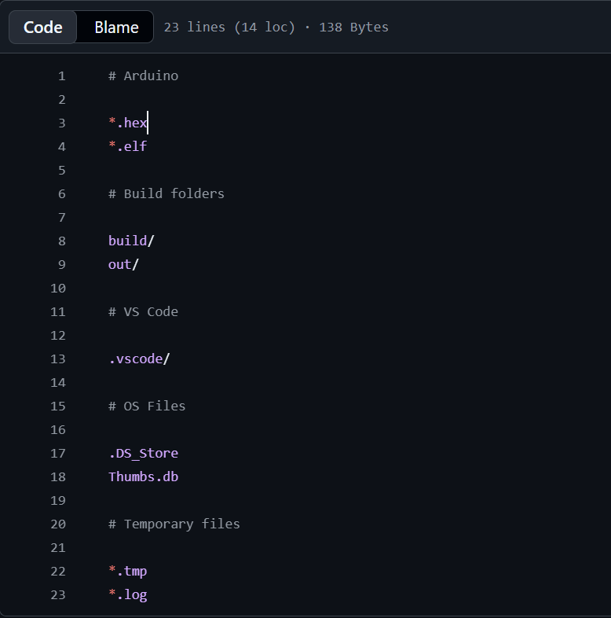

Module 2: IoT Fundamentals & Arduino Programming
Marks: 20 | Questions: Q11–Q20 | Type: Code + Explanation

📌 Hardware Required for This Module
- Arduino UNO / Nano / Mega (any one)
- LEDs (Red, Green, Blue), 220Ω resistors, Buzzer
- Push buttons, 10kΩ pull-down resistors
- Breadboard, jumper wires, USB cable

Section A: Conceptual Questions (2 marks each)
ANS11.
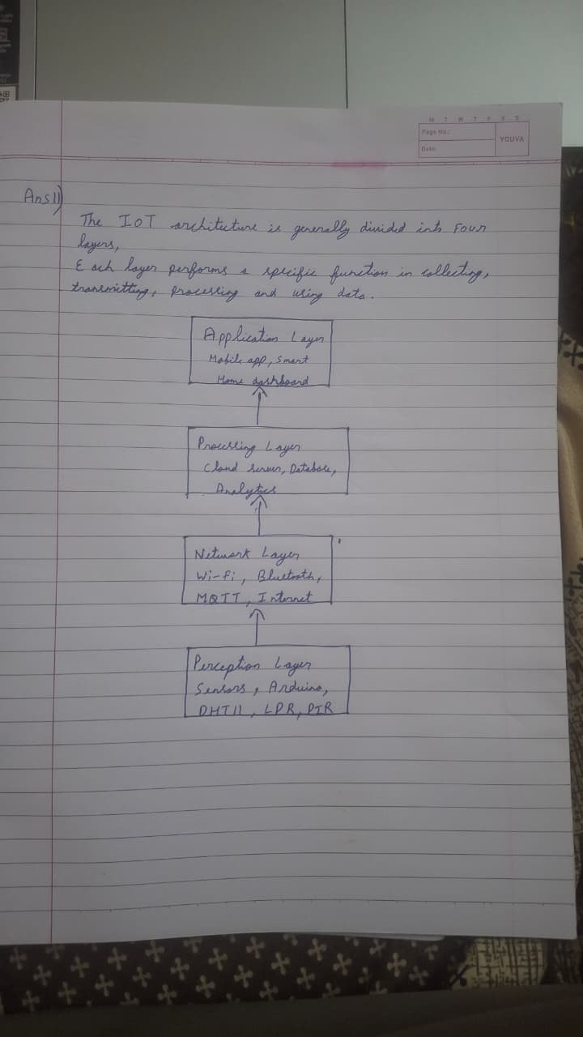
Examples of Each Layer:
- Perception Layer
  - Function: Collects data from the physical environment using sensors and devices.
  - Example: DHT11 temperature and humidity sensor.
- Network Layer
  - Function: Transfers data from sensors to servers or cloud platforms.
  - Example: Wi-Fi module (ESP32/ESP8266).
- Processing Layer
  - Function: Stores and processes the received data.
  - Example: Cloud database such as Firebase.
- Application Layer
  - Function: Provides services to the end user.
  - Example: Smart Home mobile application or weather monitoring dashboard.
Conclusion:
The Perception Layer senses the environment, the Network Layer sends the data, the Processing Layer analyzes and stores it, and the Application Layer presents useful information to the user.

Q12. Microcontroller vs Microprocessor
Fill in the following comparison table and upload a photo/scan to your GitHub repository:

Parameter | Microcontroller (Arduino UNO) | Microprocessor (Raspberry Pi)
CPU Speed
On-chip RAM
On-chip Flash
Operating System
Typical Use Case
Power Consumption

Q13. Arduino Pin Types
List and explain with examples: Digital Input, Digital Output, Analog Input, PWM Output, and I2C/SPI pins available on Arduino UNO. For each, give one real IoT use case.

Section B: Programming Tasks (4 marks each)

Q14. Traffic Light Controller
Write an Arduino program that simulates a traffic light system using 3 LEDs (Red, Yellow, Green):
- RED ON for 5 seconds → YELLOW ON for 2 seconds → GREEN ON for 4 seconds
- Add a pedestrian button (push button on pin 7): when pressed, force RED immediately and hold for 8 seconds
- Print the current light state to Serial Monitor with timestamp (millis())
Code must be uploaded to: /week2/traffic_light/traffic_light.ino

Q15. Digital Piano using Buzzer
Build a 4-key musical instrument using push buttons and a passive buzzer:
- 4 buttons mapped to notes: Do (262Hz), Re (294Hz), Mi (330Hz), Fa (349Hz)
- Button press plays the note; button release silences the buzzer
- If two buttons are pressed together: play Sol (392Hz) as a chord substitute
- Add a mode toggle (5th button): switch between Major and Minor scale
Commit separately for each feature using Git.

Q16. Serial Command Interface
Write a program that receives commands over Serial Monitor and controls hardware:
LED_ON → Turn built-in LED on
LED_OFF → Turn built-in LED off
BLINK_X → Blink LED X times (X is 1–9)
STATUS → Print pin states
RESET → Restart blink counter
Implement input validation: unknown commands should print 'ERROR: Unknown command'.

Q17. PWM Fading Night Light
Create an automatic night light that fades an LED in and out (breathing effect) continuously. Implement three modes switchable via a button: (1) Slow breathing (3-second cycle), (2) Fast pulse (0.5-second cycle), (3) SOS pattern (... --- ...). Display current mode on Serial Monitor.

Q18. State Machine Implementation
Implement a simple vending machine state machine with 4 states: IDLE, COIN_INSERTED, ITEM_SELECTED, DISPENSING. Use 3 buttons as inputs (Insert Coin, Select Item, Cancel). Use 3 LEDs to show the current state. Print all state transitions to Serial Monitor. Code must include a comment block documenting the state transition diagram.

Q19. (Theory) What is the difference between analogWrite() and analogRead() in Arduino? What is PWM and why is it used? Give a practical IoT example for each. (2 marks)

Q20. (Theory) Explain the setup() and loop() functions in Arduino. What happens if you put a long delay() inside loop()? How does this affect sensor reading responsiveness? What is the non-blocking alternative? (2 marks)

Module 3: Sensors, Actuators & Data Acquisition
Marks: 20 | Questions: Q21–Q30 | Type: Hands-On Experiments

🔬 Sensors Covered in This Module
- DHT11/DHT22 – Temperature & Humidity
- HC-SR04 – Ultrasonic Distance
- LDR – Light Dependent Resistor
- PIR – Passive Infrared Motion Sensor
- Soil Moisture Sensor, MQ-2 Gas Sensor (optional)

Section A: Sensor Experiments (4 marks each)

Q21. Environmental Monitoring Station (DHT11)
Build a mini weather station using DHT11 sensor:
- Read temperature (°C and °F) and humidity every 2 seconds
- Display readings on Serial Monitor in CSV format: timestamp,temp_C,temp_F,humidity
- Trigger a Red LED if temperature > 35°C or humidity > 80%
- Trigger a Green LED if conditions are normal
- Save 5 sample CSV readings in a file /week3/data/sample_readings.csv in your GitHub repo
Library: DHTesp or DHT by Adafruit. Include library version in README.

Q22. Ultrasonic Parking Sensor
Using HC-SR04, build a parking distance alert system:
- Distance > 50cm: No alert, Serial prints SAFE
- Distance 20–50cm: Yellow LED ON, buzzer beeps every 500ms
- Distance 10–20cm: Red LED ON, buzzer beeps every 200ms
- Distance < 10cm: All LEDs flash rapidly, buzzer continuous
- Calculate and display distance in cm using the formula: distance = (duration * 0.034) / 2
Advanced: Use millis() for non-blocking timing (no delay()). +1 bonus mark.

Q23. Smart Street Light (LDR + PIR)
Implement an intelligent street light controller:
- LDR below threshold (dark): Enable motion detection mode
- PIR detects motion at night: Turn LED on at full brightness for 30 seconds
- No motion after 30 sec: Dim LED to 20% using PWM
- LDR above threshold (daylight): Turn LED completely OFF
- Log every event to Serial: [HH:MM:SS] EVENT: description
Submit a circuit diagram sketch (hand-drawn or Tinkercad screenshot) in /week3/schematics/.

Q24. Multi-Sensor Data Logger
Build a system that reads 3 sensors simultaneously and logs structured data:
- DHT11: Temperature, Humidity
- LDR: Light level (0–1023 raw, converted to percentage)
- HC-SR04: Distance in cm
Output format every 5 seconds:
=== SENSOR LOG ===
Time : 12345 ms
Temp : 28.5 C | Humidity: 65%
Light : 73% (Bright)
Distance : 42 cm
==================
Upload 20 lines of captured Serial Monitor output as /week3/data/sensor_log.txt.

Section B: Actuator Control (2 marks each)

Q25. Servo Motor Sweep
Control a SG90 servo motor with a potentiometer. Potentiometer position (0–1023) maps to servo angle (0°–180°). Display angle in Serial Monitor. Add a button that makes the servo do one full sweep (0→180→0) when pressed. Code: /week3/servo_control/

Q26. DC Motor Speed Control with L298N
Control a DC motor through L298N driver: potentiometer sets speed (0–255 PWM), one button changes direction (Forward/Reverse), another button stops/starts the motor. Display Direction, Speed (0–100%), and State on Serial Monitor.

Q27. Relay-Controlled AC Device Simulation
Simulate a relay controlling an AC appliance (use LED as a safe simulation). DHT11 triggers relay ON when temperature > 32°C (AC turns on). Relay OFF when temp drops below 28°C (hysteresis). Add a manual override button. Log all relay state changes with temperature readings.

Q28. Keypad + LCD Display
Using a 4x4 membrane keypad and 16x2 LCD, build a password-protected access system: Display 'ENTER PIN:' on LCD, user enters 4-digit PIN, correct PIN (set in code) shows 'ACCESS GRANTED' + Green LED, wrong PIN shows 'ACCESS DENIED' + Red LED + buzzer. After 3 wrong attempts, lock for 10 seconds.

Q29. (Theory) What is sensor calibration and why is it important in IoT systems? How would you calibrate an analog soil moisture sensor to give accurate percentage readings? Describe the two-point calibration method. (2 marks)

Q30. (Theory) Explain I2C protocol with respect to IoT sensor communication. What are SDA and SCL lines? How does I2C addressing work? Name 3 common IoT sensors that use I2C. (2 marks)

Module 4: Wireless Communication & IoT Protocols
Marks: 20 | Questions: Q31–Q40 | Type: Connectivity Projects

📡 Communication Technologies Covered
- Bluetooth Classic (HC-05) & BLE (ESP32)
- Wi-Fi (ESP8266 / ESP32)
- MQTT Protocol for IoT messaging
- HTTP REST API calls from microcontroller

Section A: Bluetooth Projects (4 marks each)

Q31. Bluetooth LED Controller (HC-05 + Arduino)
Pair HC-05 with an Android phone using a Bluetooth terminal app. Commands received via Bluetooth:
'R' → Turn Red LED ON
'G' → Turn Green LED ON
'B' → Turn Blue LED ON
'X' → All LEDs OFF
'F' → Flash all LEDs 5 times
Upload code to /week4/bt_led_control/. Include pairing instructions in README (default PIN: 1234 or 0000).

Q32. Bluetooth Sensor Dashboard (ESP32 BLE)
Using ESP32, broadcast DHT11 sensor data over BLE every 3 seconds. A BLE scanning app (nRF Connect or LightBlue) should display: Temperature, Humidity, and a timestamp. Implement GATT characteristics with descriptors. Upload code to /week4/ble_sensor/. Document characteristic UUIDs in README.

Section B: Wi-Fi & Internet (4 marks each)

Q33. Wi-Fi Temperature Monitor (ESP8266/ESP32)
Connect ESP8266 to a Wi-Fi network. Build a simple web server that displays DHT11 data:
- HTML page served at the device's local IP address
- Page shows Temperature, Humidity with auto-refresh every 10 seconds
- Add a button on the web page to toggle an LED on the board
- Display uptime (how long the device has been ON) on the page
Screenshot of the working web page must be uploaded to /week4/wifi_webserver/screenshots/.

Q34. MQTT Sensor Publisher
Use ESP32 to publish DHT11 readings to a free MQTT broker (broker.hivemq.com or test.mosquitto.org):
- Topic: iitjammu/summer26/[yourname]/temperature
- Topic: iitjammu/summer26/[yourname]/humidity
- Publish every 5 seconds in JSON format: {"value": 28.5, "unit": "C", "ts": 1234567890}
- Subscribe to iitjammu/summer26/[yourname]/led_control and toggle LED based on message
Test using MQTT Explorer or MQTT.fx. Submit a screenshot showing messages received.

Appendix A: GitHub Submission Checklist

Before submitting your assignment, verify each item below:

# | Checklist Item | Done? (✓)
1 | GitHub account created with real name and profile photo
2 | Repository named: iot-summer-school-2026 (public)
3 | Folder structure: /week1, /week2, /week3, /week4, /final_project, /theory, /portfolio
4 | README.md at root level with student name, roll number, and project overview
5 | Each assignment subfolder has its own README.md
6 | All .ino files are properly commented (author, date, description at top)
7 | .gitignore file excluding build artifacts, .DS_Store, *.hex, *.elf
8 | Minimum 5 Git commits per module with descriptive commit messages
9 | No passwords or API keys committed to the repository
10 | config.h files added to .gitignore where API keys are used
11 | At least one pull request merged (Q7 collaborative exercise)
12 | Screenshot files uploaded for Wi-Fi dashboard (Q33) and MQTT (Q34)
13 | sample_readings.csv and sensor_log.txt uploaded (Q21, Q24)
14 | Circuit diagram / Tinkercad screenshots uploaded (Q23)
15 | Final project proposal and portfolio markdown files uploaded

Appendix B: Grading Rubric

Assessment Criterion | Excellent (4) | Good (3) | Adequate (2) | Poor (1)
Code Functionality | Works perfectly, handles edge cases | Works with minor issues | Partially working | Does not compile or run
Code Quality | Well-commented, clean, modular | Mostly clean with some comments | Minimal comments, messy | No comments, spaghetti code
GitHub Usage | Excellent commits, branches, PRs | Good commits and structure | Few commits, flat structure | Single commit or private repo
Documentation (README) | Complete, clear, professional | Most sections present | Brief, missing key info | Absent or placeholder
Circuit Correctness | Accurate schematic/diagram | Minor errors in diagram | Conceptually correct only | Absent or incorrect
Innovation / Bonus | All bonus implemented creatively | Some bonus attempted | Basic solution only | Requirements not met

📝 Marks Distribution Summary
- Module 1 – GitHub & Version Control: 20 marks
- Module 2 – Arduino Fundamentals: 20 marks
- Module 3 – Sensors & Actuators: 20 marks
- Module 4 – Wireless Communication: 20 marks
- Module 5 – Advanced Projects: 20 marks
TOTAL: 100 Marks | Bonus marks available up to 10 additional points

